**Batch: H2-4 Roll No.:16010122257**

**Experiment 06**

|  |
| --- |
| **Title: Working with Geospatial data** |

# Objective:

# *Search/locate and download the geospatial Data (Use same dataset if it contains location information)*

# *To learn how to visualizegeospatialdata*

# *Auto Geo-tagging*

# *Custom Geo-tagging*

# *Apply heat map*

# *Try various forms of heat maps*

# *Analyse the visualization and write your interpretation after observation on heat-map*

# [*Interactive*](https://www.youtube.com/watch?v=_h_WjKhApFc&ab_channel=HarpreetBedi)*filtering over map*

# *Following maps should be demonstrated*

# *Proportional symbol maps*

# *Choropleth maps (filled maps)*

# *Point distribution maps*

# *Density maps (heatmaps)*

# *Flow maps (path maps)*

# *Spider maps (origin-destination maps)*

# Course Outcome:

# CO1: Learn how to locate and download datasets, extract insights from that data and present their findings in a variety of different formats.

# CO3 Apply data visualization best practices

# Books/ Journals/ Websites referred:

**1.**[**https://www.ncbi.nlm.nih.gov/pmc/articles/PMC9148930/**](https://www.ncbi.nlm.nih.gov/pmc/articles/PMC9148930/)

**2.** [**https://www.visualitics.it/how-to-create-a-choropleth-map-in-tableau/?lang=en**](https://www.visualitics.it/how-to-create-a-choropleth-map-in-tableau/?lang=en)

# Resources used:

<https://www.kaggle.com/datasets/imdevskp/corona-virus-report>

# Theory:

# Definition:

# A time series in mathematics refers to a set of data points that are arranged in chronological order. Typically, these data points are recorded at regular intervals over time, creating a sequence of discrete-time data.

# Following points should be written by students

# Observation after plotting data

# Observation after plotting various forms of maps like based on visualization Que

# Interpretation of visualized map

# Note: Detail observation needed along screenshots wherever required

# 

This map shows the distribution of COVID 19 deaths using hues of the same color. The darker shades indicate more concentration of deaths in that particular region. Here we can see that the highest concentration of deaths is in USA, followed by Brazil, India, Italy, Russia and so on.

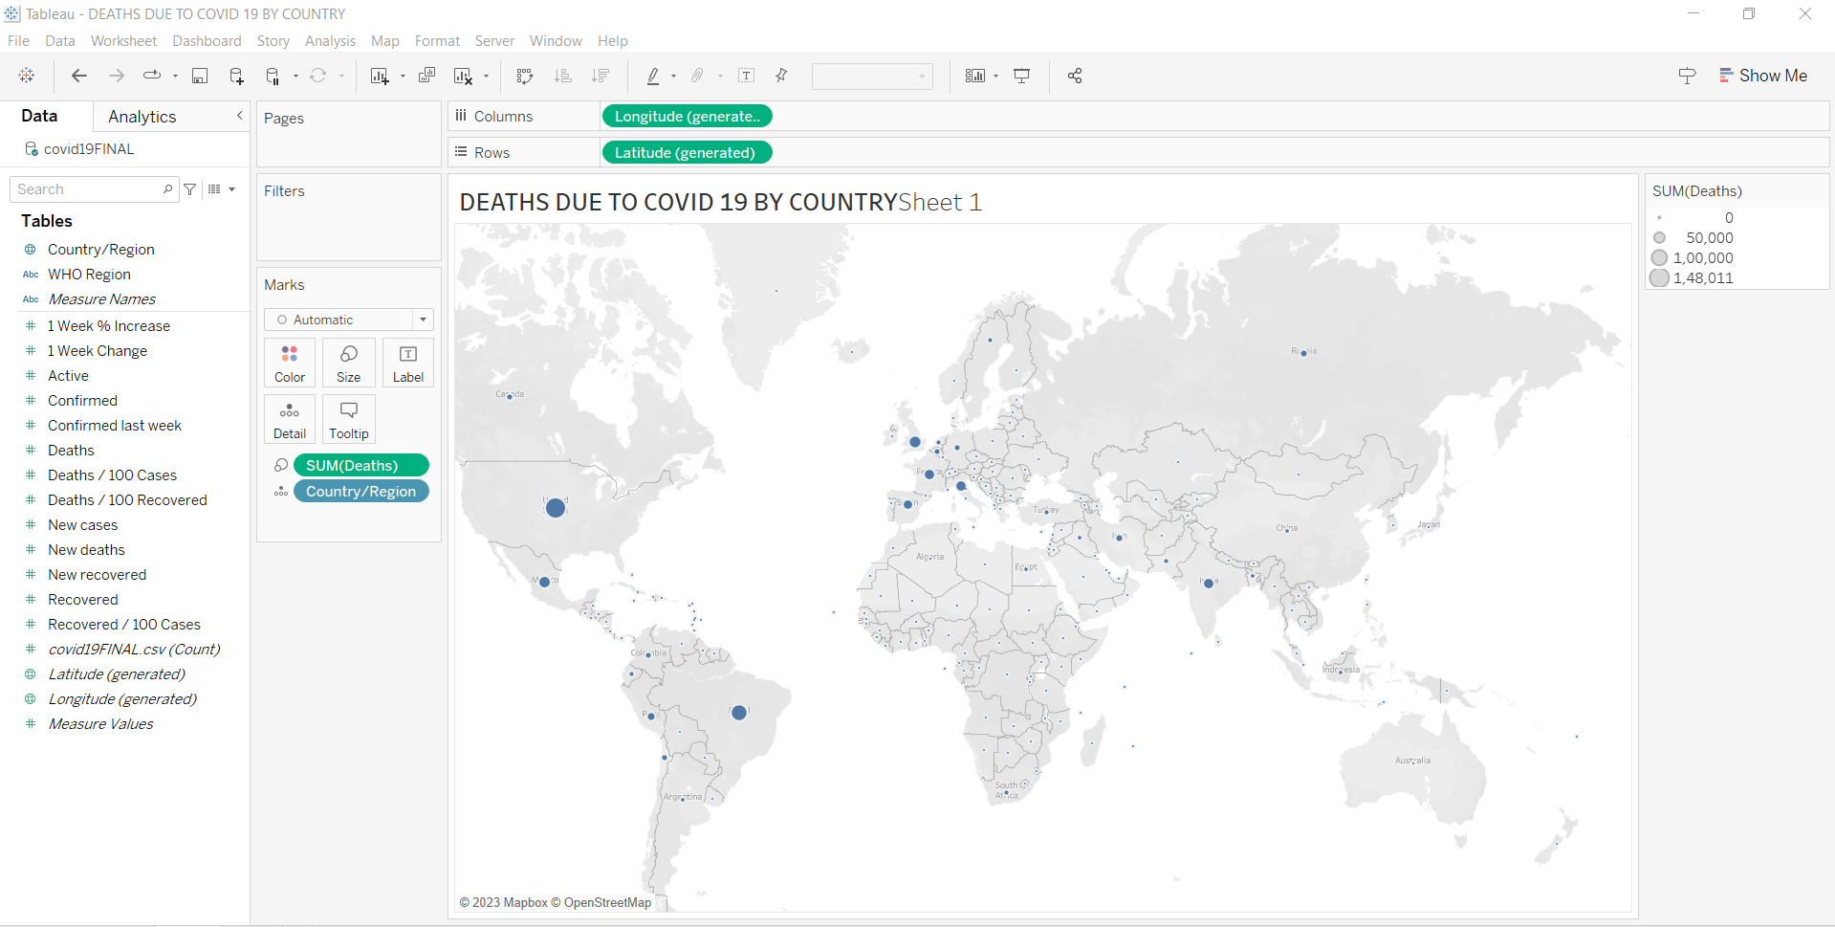

This map represents the data in form of different sizes of circle. The increasing size indicates increasing number of deaths. The scale on the right indicates the relation between the size of the circle and deaths.

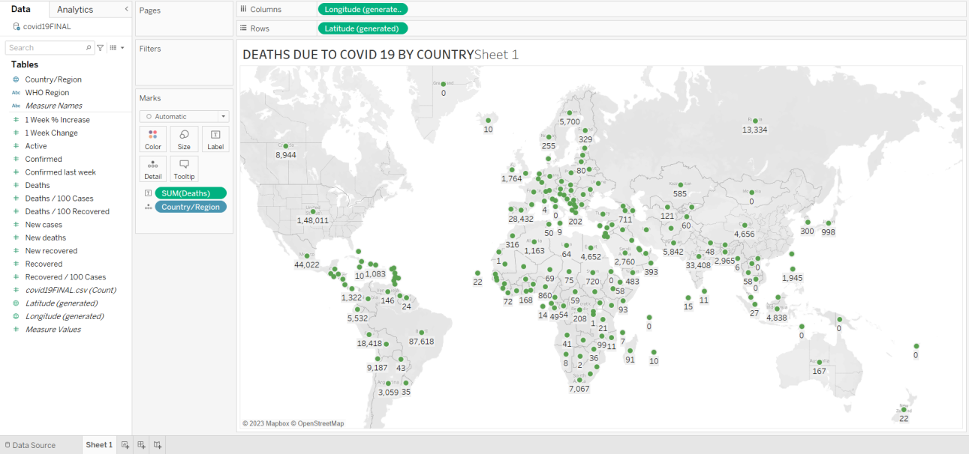

This map shows the actual count of COVID 19 deaths per country.

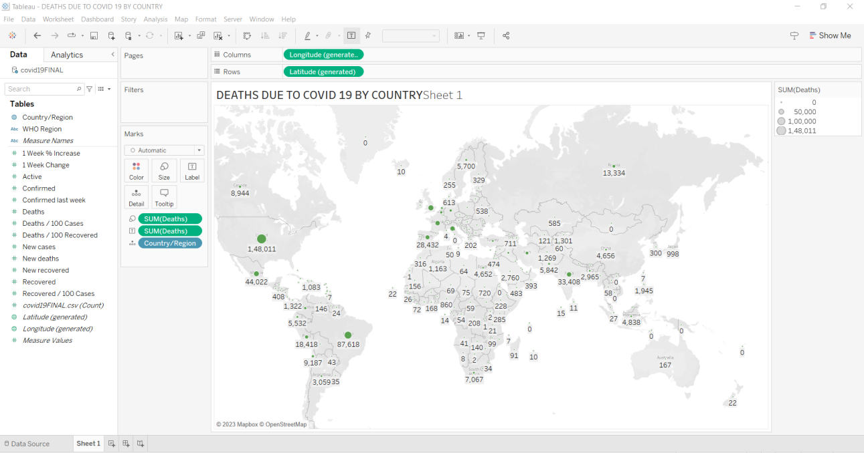

# This map is the mixture of labeled and different sized circles map. Here the data is visualized using different sized circles and is showed using labels.

# 

# This is a heat map of the deaths due to COVID 19. The different sized boxes show the concentration of deaths in a particular region.

# Conclusion (Students should write in their own words, comparative conclusion needed): In this experiment, I learned to create heat maps in the Tableau software. I could analyze the various sectors based on the color distribution and thus visualize the dataset in a clear manner at the end of the experiment,completing it successfully thus.

**Date: _____________ Signature of faculty in-charge**

# Post Lab Question:

# Explain the Choropleth maps.

# Choropleth Maps are visual representations where distinct geographical areas are shaded, colored, or patterned based on a specific data variable, allowing the visualization of patterns or variations across the depicted area.

# These maps use a range of colors to represent the data variable in each region, employing techniques like color blending, single hue progression, or transparent to opaque shading. However, relying solely on colors can make it challenging to accurately read or compare values on the map. Moreover, larger regions tend to appear more prominent than smaller ones, affecting the viewer's perception of shaded values.

# A common mistake in creating Choropleth Maps is using raw data values (like total population) instead of normalized values (such as population per square kilometer) to generate a density map, which provides a more accurate representation of the data.